Unsupervised Feature Selection for Efficient Exploration of High Dimensional Data

Evaluation Results

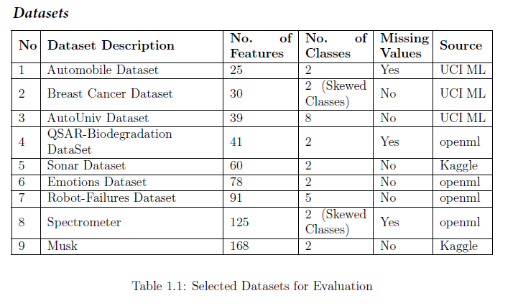

**Automobile Dataset**

**Source : https://archive.ics.uci.edu/ml/datasets/Automobile**

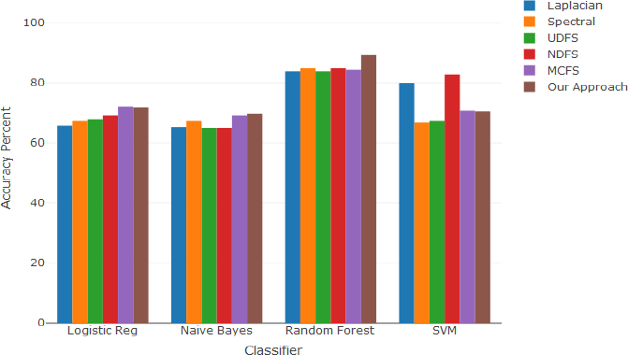

Figure 1.1: Classification Accuracy (Automobile Dataset)

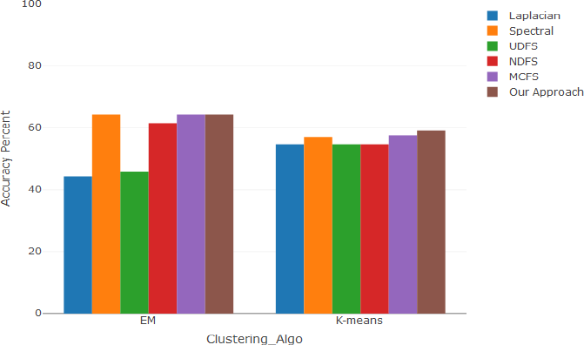

Figure 1.2: Clustering Accuracy (Automobile Dataset)

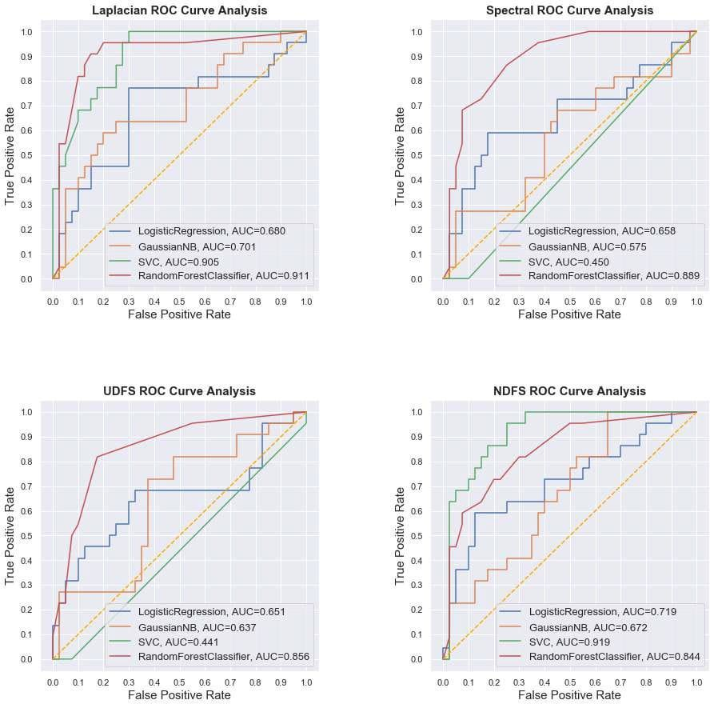

Figure 1.3: ROC Curves (Automobile Dataset) 1

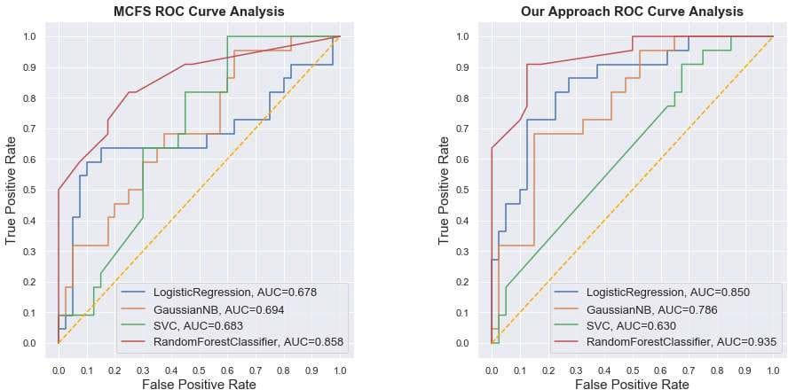

Figure 1.4: ROC Curves (Automobile Dataset) 2

**Breast Cancer Dataset**

**Source: https://archive.ics.uci.edu/ml/datasets/Breast+Cancer+Wisconsin+(Diagnostic)**

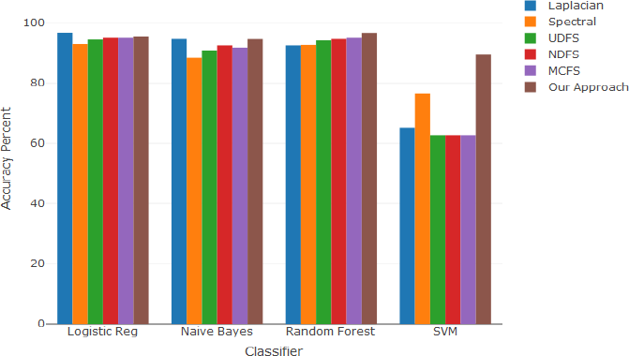

Figure 1.5: Classification Accuracy (Breast Cancer Dataset)

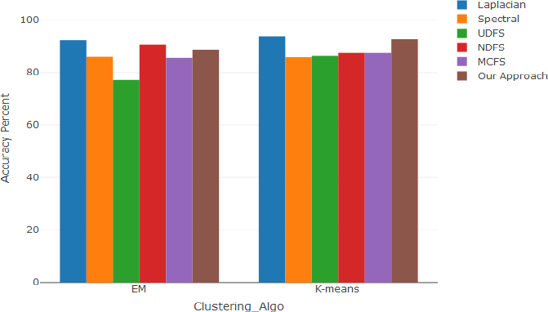

Figure 1.6: Clustering Accuracy (Breast Cancer Dataset)

## Laplacian ROC Curve Analysis Spectral ROC Curve Analysis

1.0 1.0

LogisticRegression, AUC=0.979 GaussianNB, AUC=0.976

SVC, AUC=0.895

RandomForestClassifier, AUC=0.977

LogisticRegression, AUC=0.919 GaussianNB, AUC=0.910

SVC, AUC=0.919

RandomForestClassifier, AUC=0.938

0.9 0.9

0.8 0.8

0.7 0.7

True Positive Rate

True Positive Rate

0.6 0.6

0.5 0.5

0.4 0.4

0.3 0.3

0.2 0.2

0.1 0.1

0.0 0.0

0.0 0.1 0.2 0.3 0.4 0.5 0.6 0.7 0.8 0.9 1.0

### False Positive Rate

0.0 0.1 0.2 0.3 0.4 0.5 0.6 0.7 0.8 0.9 1.0

### False Positive Rate

**UDFS ROC Curve Analysis NDFS ROC Curve Analysis**

1.0 1.0

LogisticRegression, AUC=0.563 GaussianNB, AUC=0.875

SVC, AUC=0.500

RandomForestClassifier, AUC=0.981

LogisticRegression, AUC=0.978 GaussianNB, AUC=0.971

SVC, AUC=0.123

RandomForestClassifier, AUC=0.972

0.9 0.9

0.8 0.8

0.7 0.7

True Positive Rate

True Positive Rate

0.6 0.6

0.5 0.5

0.4 0.4

0.3 0.3

0.2 0.2

0.1 0.1

0.0 0.0

0.0 0.1 0.2 0.3 0.4 0.5 0.6 0.7 0.8 0.9 1.0

### False Positive Rate

0.0 0.1 0.2 0.3 0.4 0.5 0.6 0.7 0.8 0.9 1.0

### False Positive Rate

Figure 1.7: ROC Curves (Breast Cancer Dataset) 1

**MCFS ROC Curve Analysis Our Approach ROC Curve Analysis**

1.0 1.0

LogisticRegression, AUC=0.569 GaussianNB, AUC=0.938

SVC, AUC=0.495

RandomForestClassifier, AUC=0.964

LogisticRegression, AUC=0.980 GaussianNB, AUC=0.973

SVC, AUC=0.917

RandomForestClassifier, AUC=0.979

0.9 0.9

0.8 0.8

0.7 0.7

True Positive Rate

True Positive Rate

0.6 0.6

0.5 0.5

0.4 0.4

0.3 0.3

0.2 0.2

0.1 0.1

0.0 0.0

0.0 0.1 0.2 0.3 0.4 0.5 0.6 0.7 0.8 0.9 1.0

### False Positive Rate

0.0 0.1 0.2 0.3 0.4 0.5 0.6 0.7 0.8 0.9 1.0

### False Positive Rate

Figure 1.8: ROC Curves (Breast Cancer Dataset) 2

**Auto Univ Dataset**

**Source:** [**https://www.openml.org/d/1555**](http://www.openml.org/d/1555)

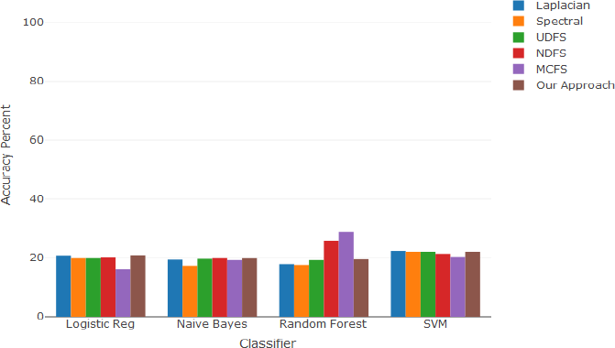

# Figure 1.9: Classification Accuracy (Auto Univ Dataset)

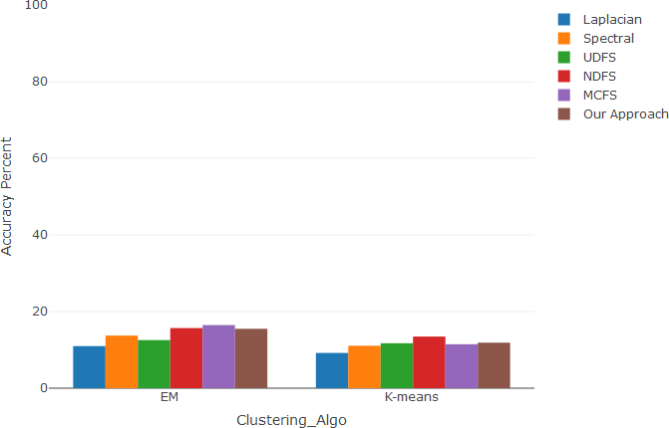

Figure 1.10: Clustering Accuracy (Auto Univ Dataset)

#### Laplacian Multi Class ROC Analysis Spectral Multi Class ROC Analysis

1.0 1.0

micro-average ROC curve (area = 0.57) macro-average ROC curve (area = 0.52) ROC curve of class 0 (area = 0.48)

ROC curve of class 1 (area = 0.47)

ROC curve of class 2 (area = 0.51) ROC curve of class 3 (area = 0.58)

ROC curve of class 4 (area = 0.52) ROC curve of class 5 (area = 0.49) ROC curve of class 6 (area = 0.46) ROC curve of class 7 (area = 0.64)

micro-average ROC curve (area = 0.57) macro-average ROC curve (area = 0.53) ROC curve of class 0 (area = 0.47)

ROC curve of class 1 (area = 0.57)

ROC curve of class 2 (area = 0.46) ROC curve of class 3 (area = 0.53)

ROC curve of class 4 (area = 0.59) ROC curve of class 5 (area = 0.55) ROC curve of class 6 (area = 0.56) ROC curve of class 7 (area = 0.51)

0.8 0.8

0.6 0.6

True Positive Rate

True Positive Rate

0.4 0.4

0.2 0.2

0.0

0.0 0.2 0.4 0.6 0.8 1.0

False Positive Rate

0.0

0.0 0.2 0.4 0.6 0.8 1.0

False Positive Rate

#### UDFS Multi Class ROC Analysis NDFS Multi Class ROC Analysis

1.0 1.0

micro-average ROC curve (area = 0.56) macro-average ROC curve (area = 0.51) ROC curve of class 0 (area = 0.47)

ROC curve of class 1 (area = 0.57) ROC curve of class 2 (area = 0.46)

ROC curve of class 3 (area = 0.53)

ROC curve of class 4 (area = 0.59) ROC curve of class 5 (area = 0.55) ROC curve of class 6 (area = 0.56) ROC curve of class 7 (area = 0.51)

micro-average ROC curve (area = 0.57) macro-average ROC curve (area = 0.54) ROC curve of class 0 (area = 0.52)

ROC curve of class 1 (area = 0.51) ROC curve of class 2 (area = 0.59)

ROC curve of class 3 (area = 0.55)

ROC curve of class 4 (area = 0.53) ROC curve of class 5 (area = 0.55) ROC curve of class 6 (area = 0.47) ROC curve of class 7 (area = 0.57)

0.8 0.8

0.6 0.6

True Positive Rate

True Positive Rate

0.4 0.4

0.2 0.2

0.0

0.0 0.2 0.4 0.6 0.8 1.0

False Positive Rate

0.0

0.0 0.2 0.4 0.6 0.8 1.0

False Positive Rate

# Figure 1.11: ROC Curves (Auto Univ Dataset) 1

#### MCFS Multi Class ROC Analysis Our Approach Multi Class ROC Analysis

1.0 1.0

0.8 0.8

0.6 0.6

True Positive Rate

True Positive Rate

|  |  |  |  |  |  |  |  |  |  |  |  |
| --- | --- | --- | --- | --- | --- | --- | --- | --- | --- | --- | --- |
| 0.4  0.2 |  | micro-average ROC curve (area = 0.59) macro-average ROC curve (area = 0.54) ROC curve of class 0 (area = 0.57)  ROC curve of class 1 (area = 0.45) ROC curve of class 2 (area = 0.54) ROC curve of class 3 (area = 0.64) ROC curve of class 4 (area = 0.53) ROC curve of class 5 (area = 0.60) ROC curve of class 6 (area = 0.42)  ROC curve of class 7 (area = 0.58) | | |  | 0.4  0.2 |  | micro-average ROC curve (area = 0.58) macro-average ROC curve (area = 0.55) ROC curve of class 0 (area = 0.57)  ROC curve of class 1 (area = 0.48) ROC curve of class 2 (area = 0.48) ROC curve of class 3 (area = 0.48) ROC curve of class 4 (area = 0.71) ROC curve of class 5 (area = 0.65) ROC curve of class 6 (area = 0.51)  ROC curve of class 7 (area = 0.54) | | | |
| 0.0 |  |  |  |  |  | 0.0 |  |  |  |  |  |
| 0.0 | 0.2 | 0.4 | 0.6 | 0.8 | 1.0 | 0.0 | 0.2 | 0.4 | 0.6 | 0.8 | 1.0 |

False Positive Rate False Positive Rate

# Figure 1.12: ROC Curves (Auto Univ Dataset) 2

**QSAR Biodegradation Dataset (No Missing Values)**

**Source: https://archive.ics.uci.edu/ml/datasets/QSAR+biodegradation**

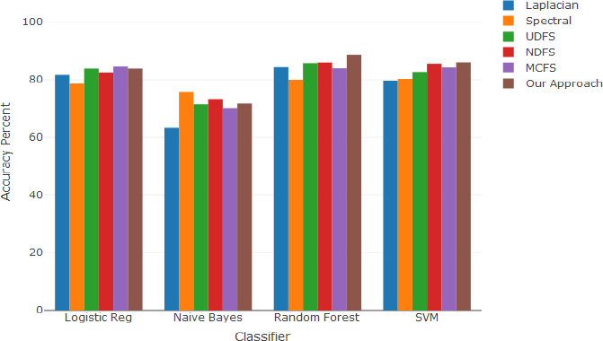

Figure 1.13: Classification Accuracy (QSAR Bio Dataset)

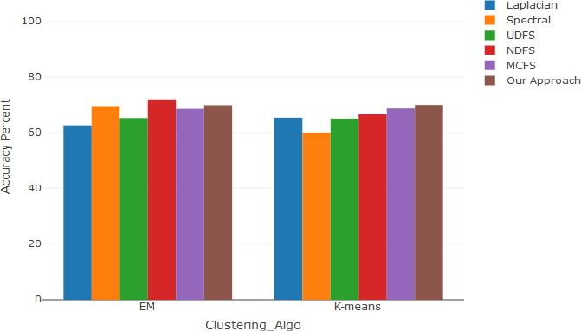

Figure 1.14: Clustering Accuracy (QSAR Bio Dataset)

## Laplacian ROC Curve Analysis Spectral ROC Curve Analysis

1.0 1.0

LogisticRegression, AUC=0.858 GaussianNB, AUC=0.803

SVC, AUC=0.817

RandomForestClassifier, AUC=0.842

LogisticRegression, AUC=0.873 GaussianNB, AUC=0.853

SVC, AUC=0.904

RandomForestClassifier, AUC=0.833

0.9 0.9

0.8 0.8

0.7 0.7

True Positive Rate

True Positive Rate

0.6 0.6

0.5 0.5

0.4 0.4

0.3 0.3

0.2 0.2

0.1 0.1

0.0 0.0

0.0 0.1 0.2 0.3 0.4 0.5 0.6 0.7 0.8 0.9 1.0

### Flase Positive Rate

0.0 0.1 0.2 0.3 0.4 0.5 0.6 0.7 0.8 0.9 1.0

### Flase Positive Rate

**UDFS ROC Curve Analysis NDFS ROC Curve Analysis**

1.0 1.0

LogisticRegression, AUC=0.874 GaussianNB, AUC=0.843

SVC, AUC=0.852

RandomForestClassifier, AUC=0.883

LogisticRegression, AUC=0.886 GaussianNB, AUC=0.862

SVC, AUC=0.882

RandomForestClassifier, AUC=0.893

0.9 0.9

0.8 0.8

0.7 0.7

True Positive Rate

True Positive Rate

0.6 0.6

0.5 0.5

0.4 0.4

0.3 0.3

0.2 0.2

0.1 0.1

0.0 0.0

0.0 0.1 0.2 0.3 0.4 0.5 0.6 0.7 0.8 0.9 1.0

### Flase Positive Rate

0.0 0.1 0.2 0.3 0.4 0.5 0.6 0.7 0.8 0.9 1.0

### Flase Positive Rate

Figure 1.15: ROC Curves (QSAR Bio Dataset) 1

**MCFS ROC Curve Analysis Our Approach ROC Curve Analysis**

1.0 1.0

LogisticRegression, AUC=0.890 GaussianNB, AUC=0.861

SVC, AUC=0.905

RandomForestClassifier, AUC=0.902

LogisticRegression, AUC=0.877 GaussianNB, AUC=0.843

SVC, AUC=0.866

RandomForestClassifier, AUC=0.885

0.9 0.9

0.8 0.8

0.7 0.7

True Positive Rate

True Positive Rate

0.6 0.6

0.5 0.5

0.4 0.4

0.3 0.3

0.2 0.2

0.1 0.1

0.0 0.0

0.0 0.1 0.2 0.3 0.4 0.5 0.6 0.7 0.8 0.9 1.0

### Flase Positive Rate

0.0 0.1 0.2 0.3 0.4 0.5 0.6 0.7 0.8 0.9 1.0

### Flase Positive Rate

Figure 1.16: ROC Curves (QSAR Bio Dataset) 2

**QSAR Biodegradation Dataset (With Missing Values) Source: https://archive.ics.uci.edu/ml/datasets/QSAR+biodegradation**

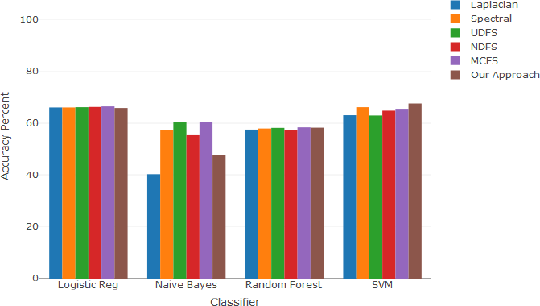

# Figure 1.17: Classification Accuracy (QSAR Bio Dataset)

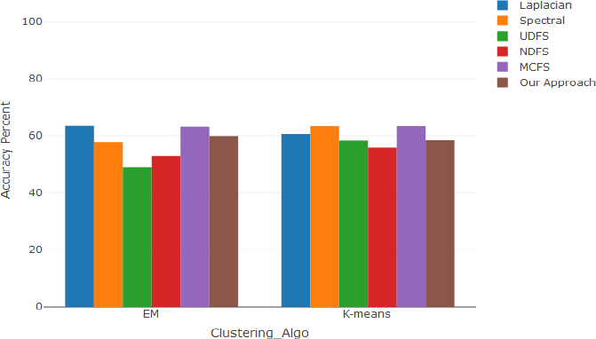

Figure 1.18: Clustering Accuracy (QSAR Bio Dataset)

## Laplacian ROC Curve Analysis Spectral ROC Curve Analysis

1.0 1.0

LogisticRegression, AUC=0.498 GaussianNB, AUC=0.528

SVC, AUC=0.585

RandomForestClassifier, AUC=0.463

LogisticRegression, AUC=0.481 GaussianNB, AUC=0.482

SVC, AUC=0.532

RandomForestClassifier, AUC=0.434

0.9 0.9

0.8 0.8

0.7 0.7

True Positive Rate

True Positive Rate

0.6 0.6

0.5 0.5

0.4 0.4

0.3 0.3

0.2 0.2

0.1 0.1

0.0 0.0

0.0 0.1 0.2 0.3 0.4 0.5 0.6 0.7 0.8 0.9 1.0

### False Positive Rate

0.0 0.1 0.2 0.3 0.4 0.5 0.6 0.7 0.8 0.9 1.0

### False Positive Rate

**UDFS ROC Curve Analysis NDFS ROC Curve Analysis**

1.0 1.0

LogisticRegression, AUC=0.491 GaussianNB, AUC=0.452

SVC, AUC=0.566

RandomForestClassifier, AUC=0.377

LogisticRegression, AUC=0.525 GaussianNB, AUC=0.456

SVC, AUC=0.601

RandomForestClassifier, AUC=0.457

0.9 0.9

0.8 0.8

0.7 0.7

True Positive Rate

True Positive Rate

0.6 0.6

0.5 0.5

0.4 0.4

0.3 0.3

0.2 0.2

0.1 0.1

0.0 0.0

0.0 0.1 0.2 0.3 0.4 0.5 0.6 0.7 0.8 0.9 1.0

### False Positive Rate

0.0 0.1 0.2 0.3 0.4 0.5 0.6 0.7 0.8 0.9 1.0

### False Positive Rate

Figure 1.19: ROC Curves (QSAR Bio Dataset) 1

**MCFS ROC Curve Analysis Our Approach ROC Curve Analysis**

1.0 1.0

LogisticRegression, AUC=0.531 GaussianNB, AUC=0.499

SVC, AUC=0.557

RandomForestClassifier, AUC=0.447

LogisticRegression, AUC=0.424 GaussianNB, AUC=0.477

SVC, AUC=0.533

RandomForestClassifier, AUC=0.495

0.9 0.9

0.8 0.8

0.7 0.7

True Positive Rate

True Positive Rate

0.6 0.6

0.5 0.5

0.4 0.4

0.3 0.3

0.2 0.2

0.1 0.1

0.0 0.0

0.0 0.1 0.2 0.3 0.4 0.5 0.6 0.7 0.8 0.9 1.0

### False Positive Rate

0.0 0.1 0.2 0.3 0.4 0.5 0.6 0.7 0.8 0.9 1.0

### False Positive Rate

Figure 1.20: ROC Curves (QSAR Bio Dataset) 2

**Sonar Dataset**

**Source:** [**http://archive.ics.uci.edu/ml/datasets/connectionist+bench+(sonar,+mines+vs.+rocks)**](http://archive.ics.uci.edu/ml/datasets/connectionist%2Bbench%2B(sonar%2C%2Bmines%2Bvs.%2Brocks))

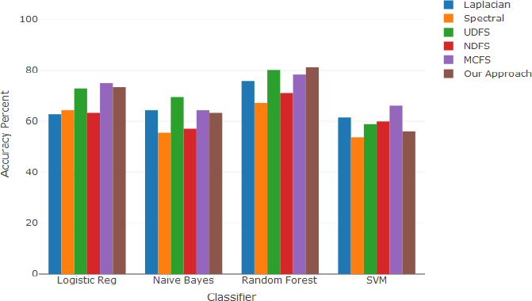

Figure 1.21: Classification Accuracy (Sonar Dataset)

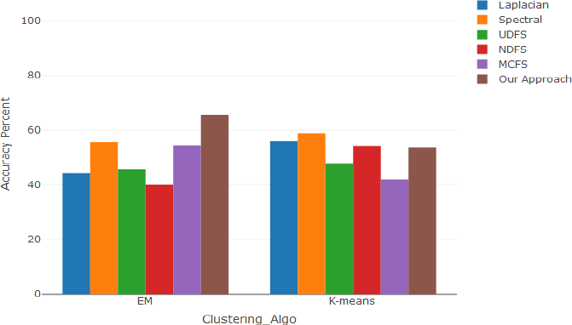

Figure 1.22: Clustering Accuracy (Sonar Dataset)

**Laplacian ROC Curve Analysis Spectral ROC Curve Analysis**

1.0 1.0

LogisticRegression, AUC=0.433 GaussianNB, AUC=0.466

SVC, AUC=0.541

RandomForestClassifier, AUC=0.413

LogisticRegression, AUC=0.445 GaussianNB, AUC=0.435

SVC, AUC=0.500

RandomForestClassifier, AUC=0.433

0.9 0.9

0.8 0.8

0.7 0.7

True Positive Rate

True Positive Rate

0.6 0.6

0.5 0.5

0.4 0.4

0.3 0.3

0.2 0.2

0.1 0.1

0.0 0.0

0.0 0.1 0.2 0.3 0.4 0.5 0.6 0.7 0.8 0.9 1.0

### False Positive Rate

0.0 0.1 0.2 0.3 0.4 0.5 0.6 0.7 0.8 0.9 1.0

### False Positive Rate

**UDFS ROC Curve Analysis NDFS ROC Curve Analysis**

1.0 1.0

LogisticRegression, AUC=0.484 GaussianNB, AUC=0.463

SVC, AUC=0.531

RandomForestClassifier, AUC=0.470

LogisticRegression, AUC=0.453 GaussianNB, AUC=0.461

SVC, AUC=0.530

RandomForestClassifier, AUC=0.450

0.9 0.9

0.8 0.8

0.7 0.7

True Positive Rate

True Positive Rate

0.6 0.6

0.5 0.5

0.4 0.4

0.3 0.3

0.2 0.2

0.1 0.1

0.0 0.0

0.0 0.1 0.2 0.3 0.4 0.5 0.6 0.7 0.8 0.9 1.0

### False Positive Rate

0.0 0.1 0.2 0.3 0.4 0.5 0.6 0.7 0.8 0.9 1.0

### False Positive Rate

Figure 1.23: ROC Curves (Sonar Dataset) 1

**MCFS ROC Curve Analysis Our Approach ROC Curve Analysis**

1.0 1.0

LogisticRegression, AUC=0.513 GaussianNB, AUC=0.597

SVC, AUC=0.504

RandomForestClassifier, AUC=0.515

LogisticRegression, AUC=0.642 GaussianNB, AUC=0.845

SVC, AUC=0.573

RandomForestClassifier, AUC=0.864

0.9 0.9

0.8 0.8

0.7 0.7

True Positive Rate

True Positive Rate

0.6 0.6

0.5 0.5

0.4 0.4

0.3 0.3

0.2 0.2

0.1 0.1

0.0 0.0

0.0 0.1 0.2 0.3 0.4 0.5 0.6 0.7 0.8 0.9 1.0

### False Positive Rate

0.0 0.1 0.2 0.3 0.4 0.5 0.6 0.7 0.8 0.9 1.0

### False Positive Rate

Figure 1.24: ROC Curves (Sonar Dataset) 2

**Emotions Dataset**

**Source:** [**https://www.openml.org/d/4058**](http://www.openml.org/d/40589)**9**

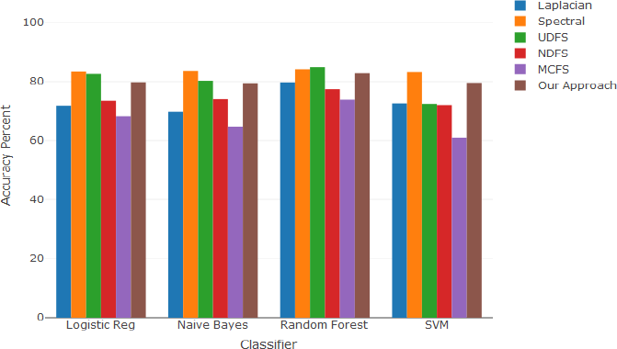

# Figure 1.25: Classification Accuracy (Emotions Dataset)

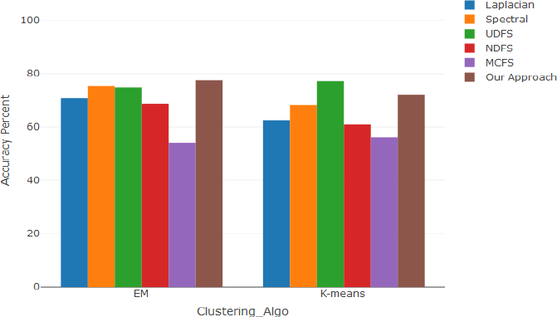

Figure 1.26: Clustering Accuracy (Emotions Dataset)

## Laplacian ROC Curve Analysis Spectral ROC Curve Analysis

1.0 1.0

LogisticRegression, AUC=0.788 GaussianNB, AUC=0.776

SVC, AUC=0.774

RandomForestClassifier, AUC=0.882

LogisticRegression, AUC=0.874 GaussianNB, AUC=0.878

SVC, AUC=0.889

RandomForestClassifier, AUC=0.874

0.9 0.9

0.8 0.8

0.7 0.7

True Positive Rate

True Positive Rate

0.6 0.6

0.5 0.5

0.4 0.4

0.3 0.3

0.2 0.2

0.1 0.1

0.0 0.0

0.0 0.1 0.2 0.3 0.4 0.5 0.6 0.7 0.8 0.9 1.0

### False Positive Rate

0.0 0.1 0.2 0.3 0.4 0.5 0.6 0.7 0.8 0.9 1.0

### False Positive Rate

**UDFS ROC Curve Analysis NDFS ROC Curve Analysis**

1.0 1.0

LogisticRegression, AUC=0.889 GaussianNB, AUC=0.868

SVC, AUC=0.780

RandomForestClassifier, AUC=0.878

LogisticRegression, AUC=0.772 GaussianNB, AUC=0.795

SVC, AUC=0.777

RandomForestClassifier, AUC=0.811

0.9 0.9

0.8 0.8

0.7 0.7

True Positive Rate

True Positive Rate

0.6 0.6

0.5 0.5

0.4 0.4

0.3 0.3

0.2 0.2

0.1 0.1

0.0 0.0

0.0 0.1 0.2 0.3 0.4 0.5 0.6 0.7 0.8 0.9 1.0

### False Positive Rate

0.0 0.1 0.2 0.3 0.4 0.5 0.6 0.7 0.8 0.9 1.0

### False Positive Rate

Figure 1.27: ROC Curves (Emotions Dataset) 1

**MCFS ROC Curve Analysis Our Approach ROC Curve Analysis**

1.0 1.0

LogisticRegression, AUC=0.698 GaussianNB, AUC=0.697

SVC, AUC=0.674

RandomForestClassifier, AUC=0.785

LogisticRegression, AUC=0.832 GaussianNB, AUC=0.836

SVC, AUC=0.843

RandomForestClassifier, AUC=0.858

0.9 0.9

0.8 0.8

0.7 0.7

True Positive Rate

True Positive Rate

0.6 0.6

0.5 0.5

0.4 0.4

0.3 0.3

0.2 0.2

0.1 0.1

0.0 0.0

0.0 0.1 0.2 0.3 0.4 0.5 0.6 0.7 0.8 0.9 1.0

### False Positive Rate

0.0 0.1 0.2 0.3 0.4 0.5 0.6 0.7 0.8 0.9 1.0

### False Positive Rate

Figure 1.28: ROC Curves (Emotions Dataset) 2

**Robot-Fail Dataset**

**Source:** [**https://www.openml.org/d/1520**](http://www.openml.org/d/1520)

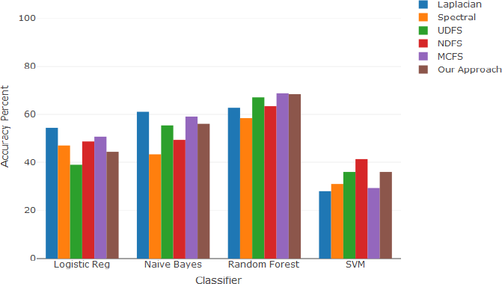

# Figure 1.29: Classification Accuracy (Robot-Fail Dataset)

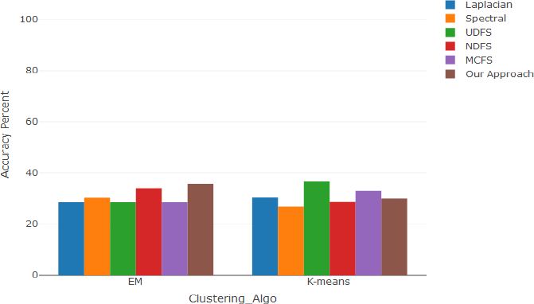

Figure 1.30: Clustering Accuracy (Robot-Fail Dataset)

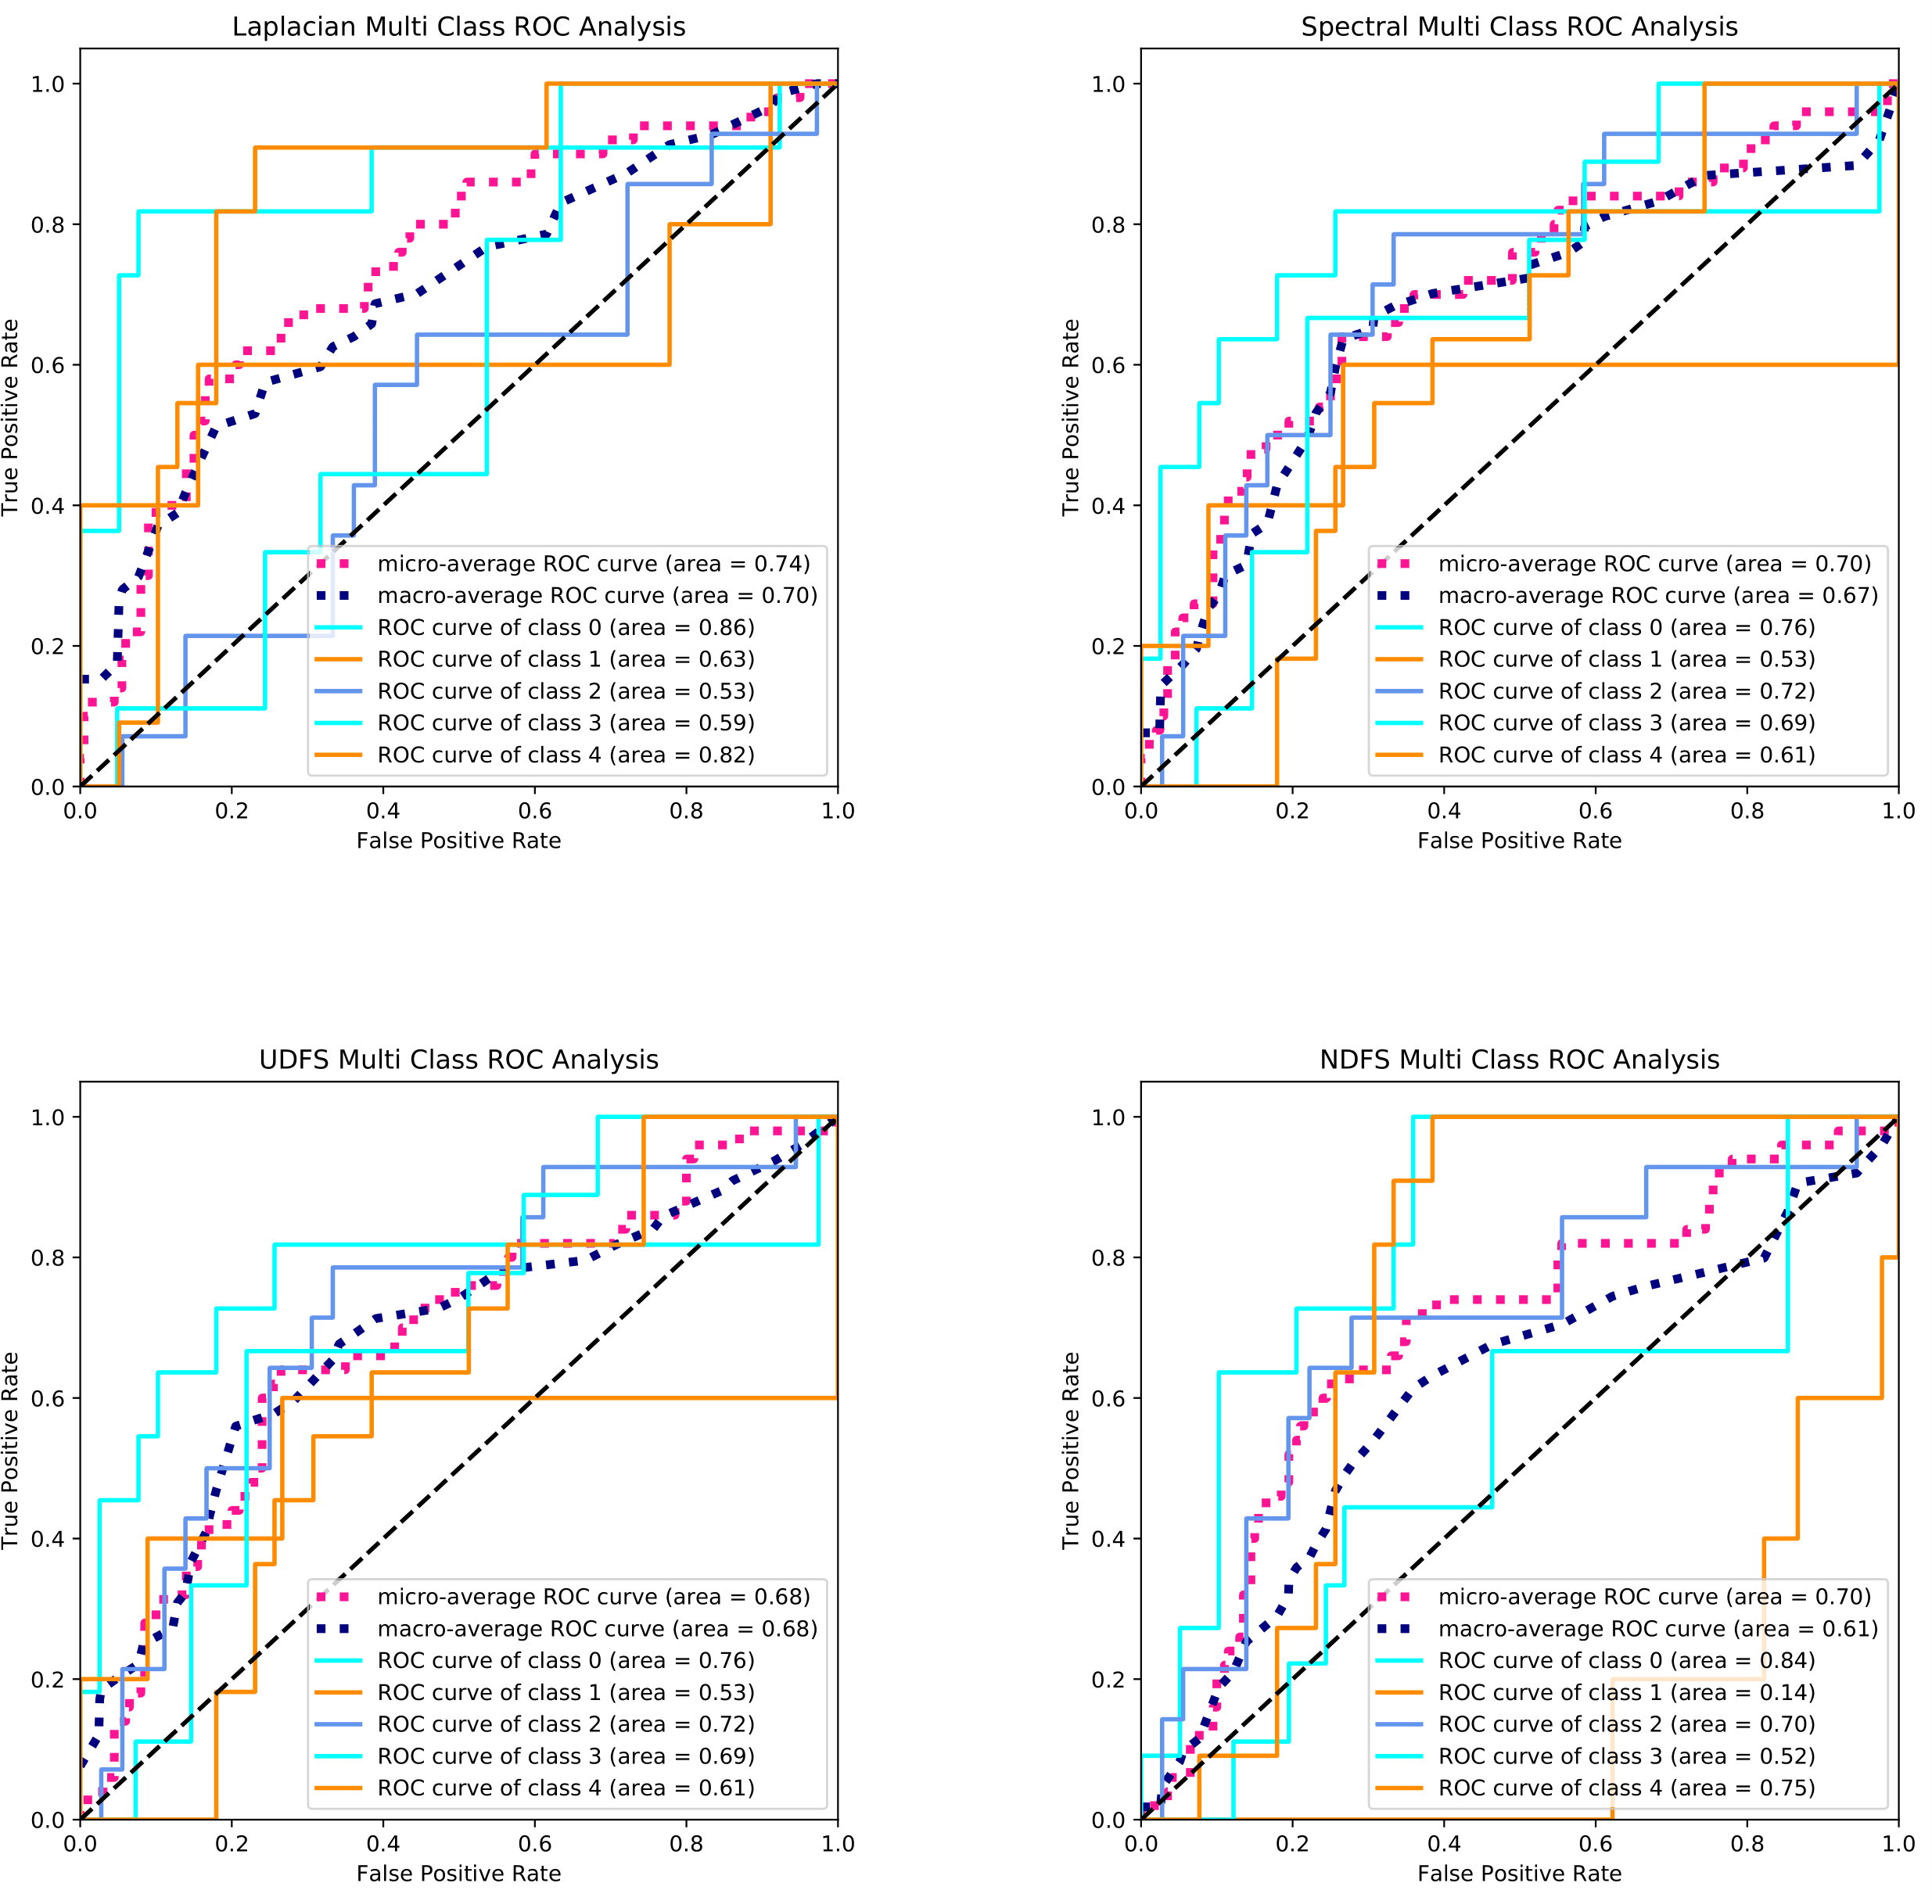

Figure 1.31: ROC Curves (Robot-Fail Dataset)(1) Dataset) 1

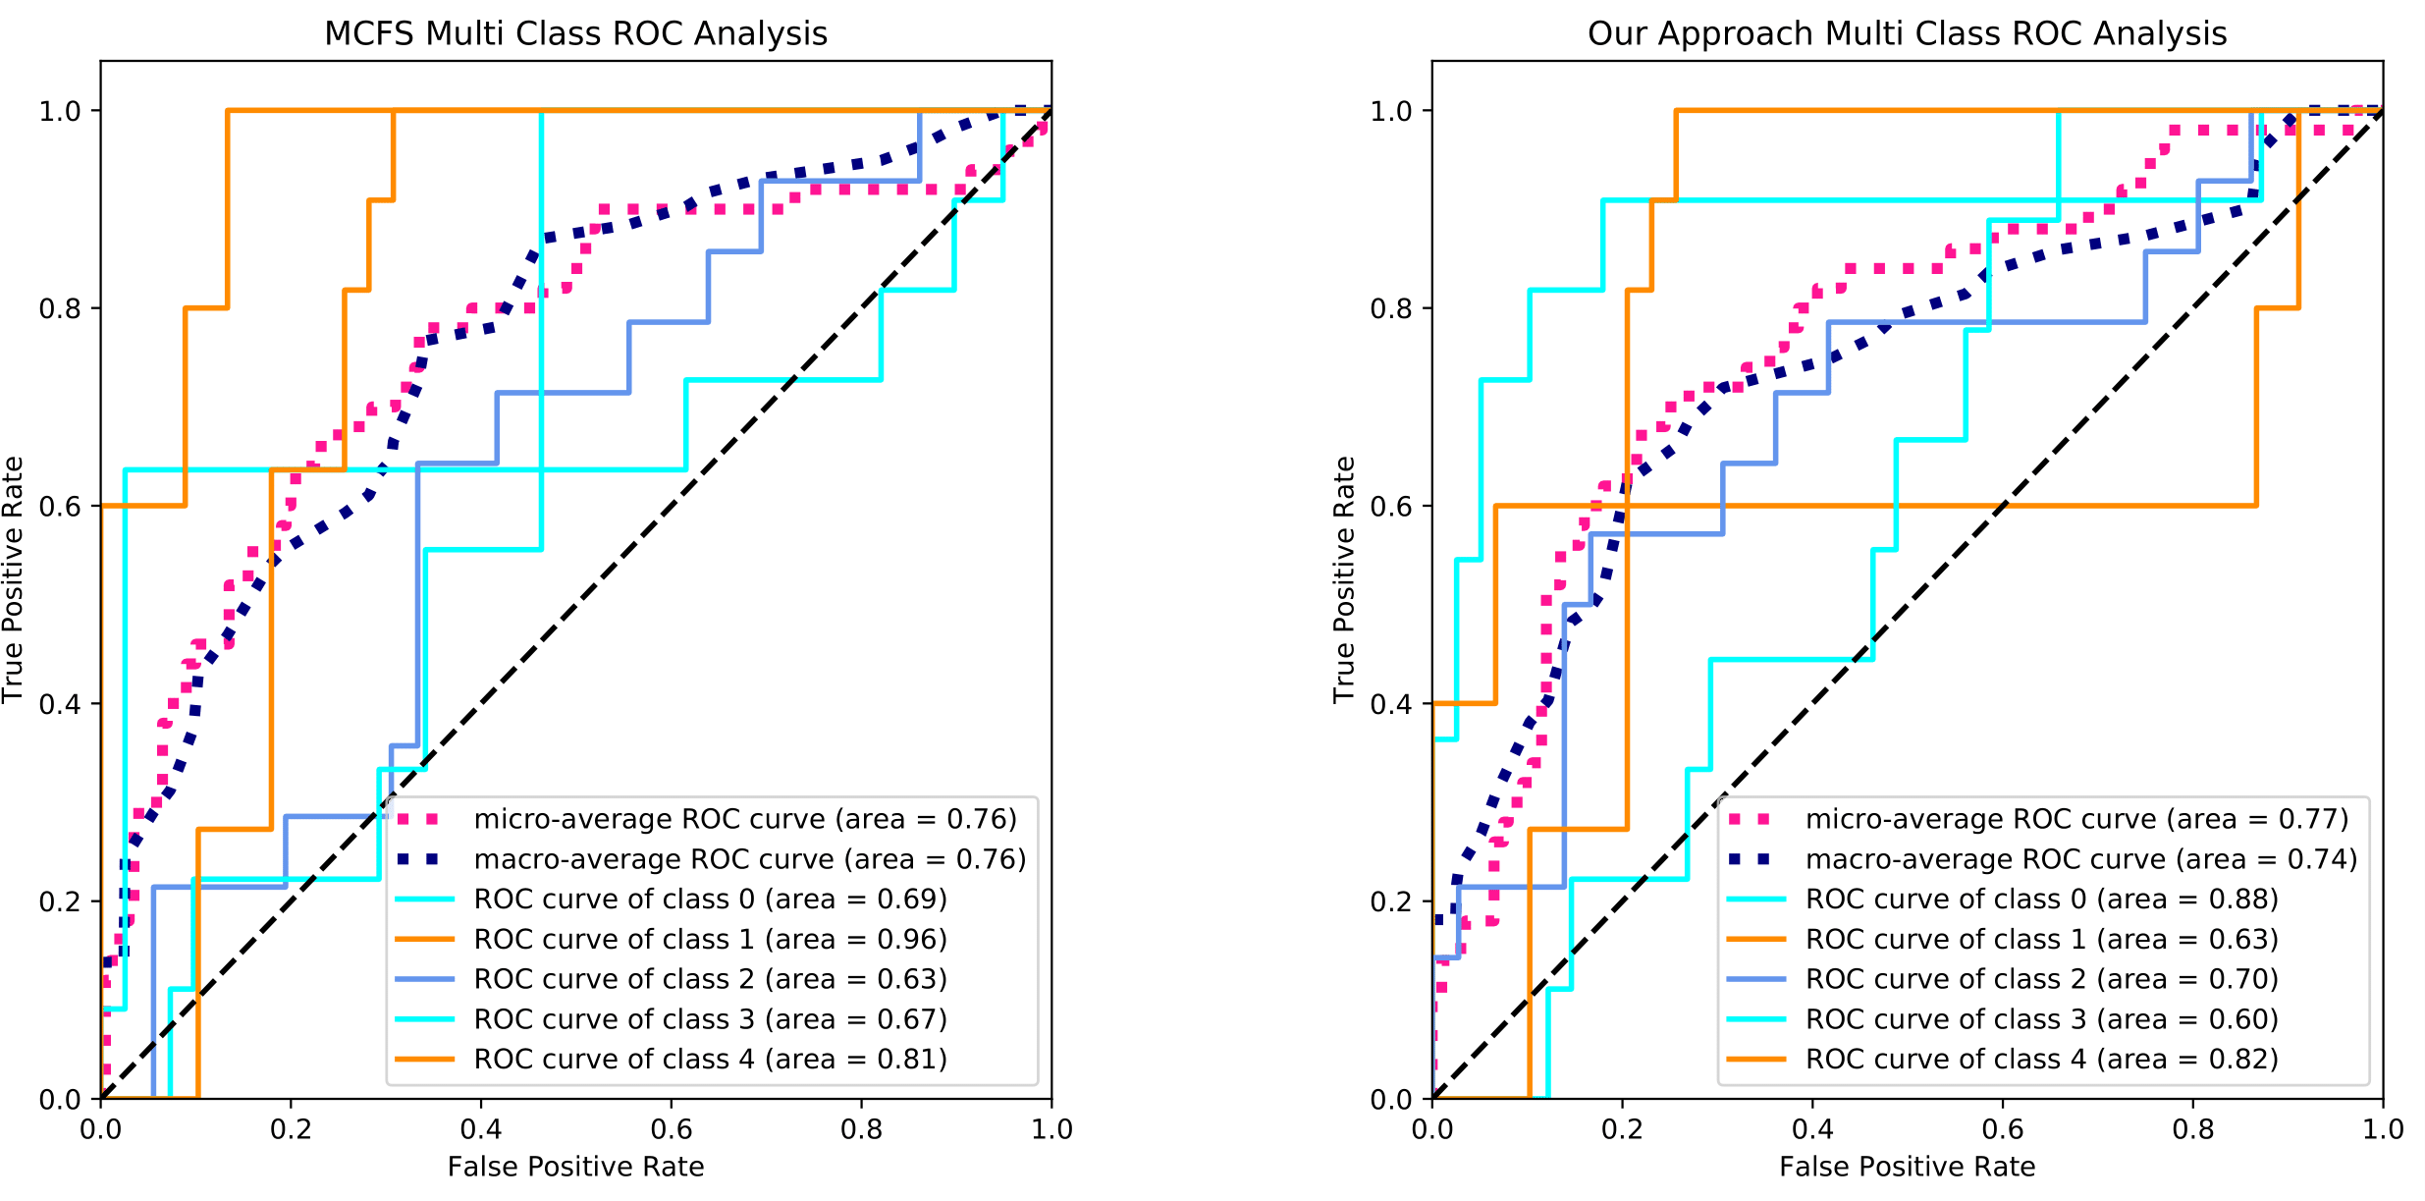

Figure 1.32: ROC Curves (Robot-Fail Dataset)(1) Dataset) 2

**Spectrometer Dataset**

**Source:** [**https://www.openml.org/d/954**](http://www.openml.org/d/954)

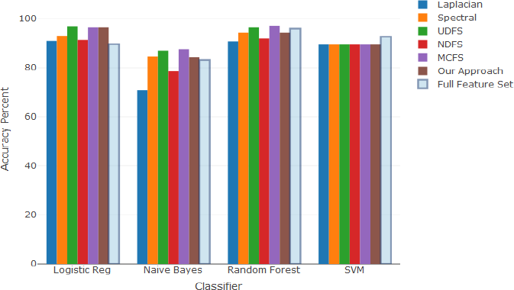

# Figure 1.33: Classification Accuracy (Spectrometer Dataset)

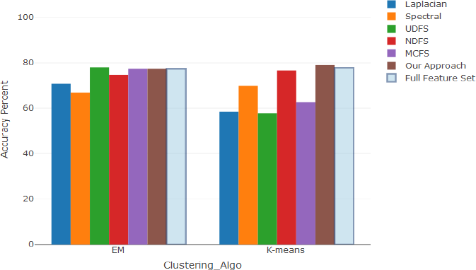

Figure 1.34: Clustering Accuracy (Spectrometer Dataset)

## Laplacian ROC Curve Analysis Spectral ROC Curve Analysis

1.0 1.0

LogisticRegression, AUC=0.876 GaussianNB, AUC=0.902

SVC, AUC=0.500

RandomForestClassifier, AUC=0.874

LogisticRegression, AUC=0.930 GaussianNB, AUC=0.951

SVC, AUC=0.500

RandomForestClassifier, AUC=0.879

0.9 0.9

0.8 0.8

0.7 0.7

True Positive Rate

True Positive Rate

0.6 0.6

0.5 0.5

0.4 0.4

0.3 0.3

0.2 0.2

0.1 0.1

0.0 0.0

0.0 0.1 0.2 0.3 0.4 0.5 0.6 0.7 0.8 0.9 1.0

### False Positive Rate

0.0 0.1 0.2 0.3 0.4 0.5 0.6 0.7 0.8 0.9 1.0

### False Positive Rate

**UDFS ROC Curve Analysis NDFS ROC Curve Analysis**

1.0 1.0

LogisticRegression, AUC=0.982 GaussianNB, AUC=0.977

SVC, AUC=0.500

RandomForestClassifier, AUC=0.920

LogisticRegression, AUC=0.939 GaussianNB, AUC=0.901

SVC, AUC=0.500

RandomForestClassifier, AUC=0.868

0.9 0.9

0.8 0.8

0.7 0.7

True Positive Rate

True Positive Rate

0.6 0.6

0.5 0.5

0.4 0.4

0.3 0.3

0.2 0.2

0.1 0.1

0.0 0.0

0.0 0.1 0.2 0.3 0.4 0.5 0.6 0.7 0.8 0.9 1.0

### False Positive Rate

0.0 0.1 0.2 0.3 0.4 0.5 0.6 0.7 0.8 0.9 1.0

### False Positive Rate

Figure 1.35: ROC Curves (Spectrometer Dataset) 1

**MCFS ROC Curve Analysis Our Approach ROC Curve Analysis**

1.0 1.0

LogisticRegression, AUC=0.998 GaussianNB, AUC=0.976

SVC, AUC=0.500

RandomForestClassifier, AUC=0.985

LogisticRegression, AUC=0.988 GaussianNB, AUC=0.954

SVC, AUC=0.500

RandomForestClassifier, AUC=0.974

0.9 0.9

0.8 0.8

0.7 0.7

True Positive Rate

True Positive Rate

0.6 0.6

0.5 0.5

0.4 0.4

0.3 0.3

0.2 0.2

0.1 0.1

0.0 0.0

0.0 0.1 0.2 0.3 0.4 0.5 0.6 0.7 0.8 0.9 1.0

### False Positive Rate

0.0 0.1 0.2 0.3 0.4 0.5 0.6 0.7 0.8 0.9 1.0

### False Positive Rate

Figure 1.36: ROC Curves (Spectrometer Dataset) 2

**Musk Dataset**

**Source:** [**https://www.openml.org/d/40666**](http://www.openml.org/d/40666)

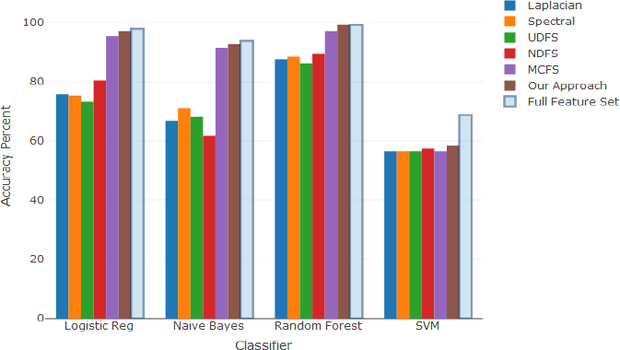

# Figure 1.37: Classification Accuracy (Musk Dataset)

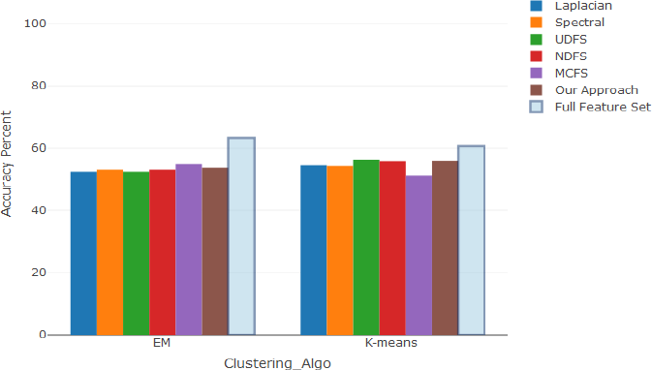

Figure 1.38: Clustering Accuracy (Musk Dataset)

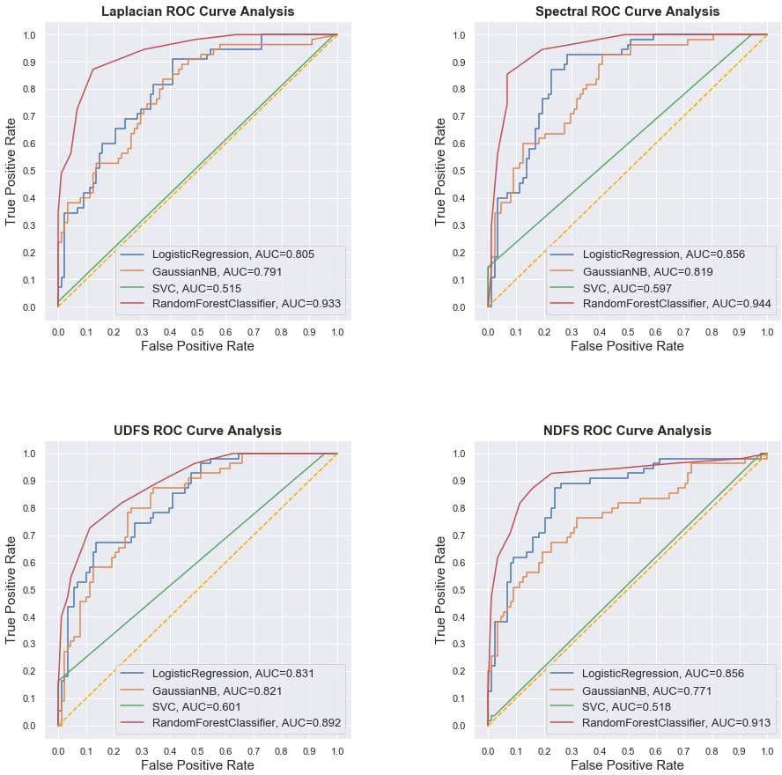

Figure 1.39: ROC Curves (Musk Dataset) 1

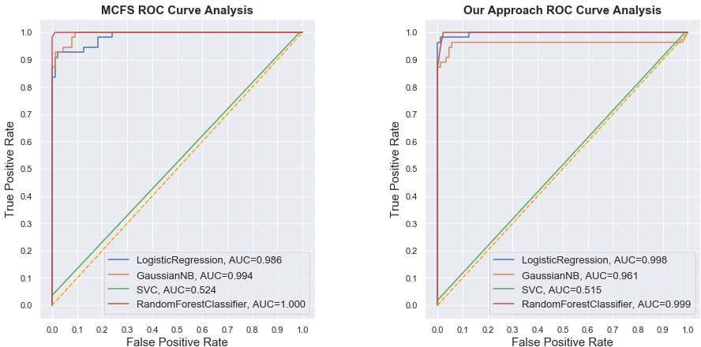

Figure 1.40: ROC Curves (Musk Dataset) 2